AIT 524, Week 02:

**TEAM MEMBER:**

Ibifubara Iganibo, Mochammad Saputra, Tanmoy Chowdhury,

Problem 01:

|  |  |  |  |  |
| --- | --- | --- | --- | --- |
| Scenario | Entities | Attributes | Relationship type | Explanation |
| 1 | Customer, Car | Customer ID, Customer Name,  Car VIN,  Car Model,  Car Make, | One to many | One instance of customer is related to many instances of car |
| 2 | Student,  Class | Student ID,  Student Name,  Class code,  Class name,  Class location | Many to Many | Many instances of student are related to many instances of class |
| 3 | Department,  Employee | Employee ID,  Employee Name,  Department Name,  Department Location | One to One | One instance of Department is related to one instance of employee |

Problem 02:

|  |  |  |  |
| --- | --- | --- | --- |
| Scenario | Entity | Relationship | Business Rule |
| 1 | Two | 1:M | One instance of one entity is related to M instances of another entity |
| 2 | Two | 1:1 | One instance of one entity is related to one instance of another entity |
| 3 | Two | M:N | M instances of one entity is related to N instances of another entity |

Problem 03:

|  |  |  |
| --- | --- | --- |
| Case | Entities | Relationship |
|  | Painter, Paintings | One to Many |
|  | Gallery, Paintings | One to Many |
|  | Painter, Gallery | Many to Many |
|  |  |  |

Problem 04:

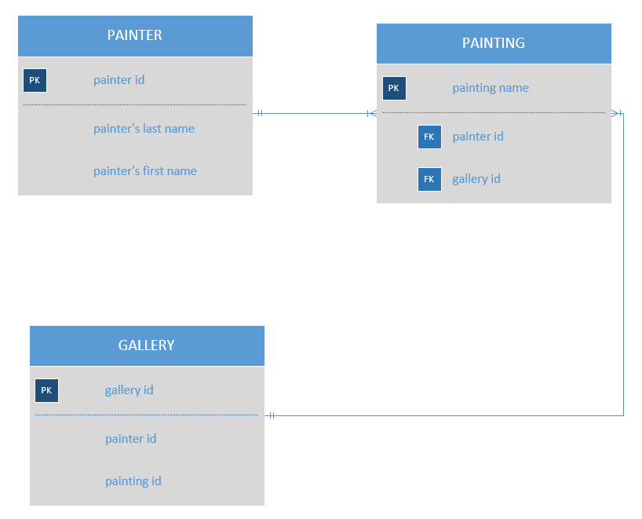

Problem 05:

